

American International University- Bangladesh

CSC 3222: Web Technologies

CO1.1 and CO2.1 Evaluation

Project Report

Fall 23-24

Project Title: Hotel & Car Booking system

Section: C

|  |  |
| --- | --- |
| Student Name | Student Id |
| SAKIB, SAFKAT MAHMUD | 21-44389-1 |
| SOUMIK, SK.MD AL OWASI | 21-44424-1 |
| AHMAD, ASIF | 21-44388-1 |
|  |  |

Introduction:

We are carrying out this project to create an organized and user-friendly platform for travelers. The goal of our project is to simply travel by providing an efficient and integrated platform where user can book accommodation and rent cars according to their needs while also providing a well-managed platform for the service owners to manage their services.

Background Study

Our project is mainly based on the features and functions of Booking.com and bdtickets.com. Booking.com is one of the largest online travel agencies. On the other hand, bdtickets.com is an online Bangladeshi platform to buy bus/plane/launch tickets. In Booking.com, the user logs in where he/she can search for a hotel room with their desired requirements and book it for their favorable date. He/she can also rent a car through that website based on their needs. In bdtickets.com, the user can buy a ticket by entering their destination and time from their desired location and can buy it instantly after completing online payment. In this project we combined the functions and features of both websites, Ffor example the book a room feature from booking.com and buy a bus ticket from bdtickets.com which will simultaneously be available in our website. Our aim is to make it easier for travelers to travel and get all the necessary features in one website, hence the combination of this features.

Requirement Analysis:

1. User Category:

There are 4-types of Users here. They are:

* User
* Hotel Owner
* Car Owner
* Admin

1. Feature List:

* In this project the “User” has the following features:
* Hotel Searching
* Car Searching
* Hotel Booking
* Car Booking
* Booking History
* Booking Cancellation
* Profile Management

In this project the “Hotel Owner” has the following features:

* Hotel Management
* Room Management
* Hotel Booking Management
* Hotel Booking Cancellation
* Hotel Booking Confirmation

In this project the “Car Owner” has the following features:

* Car Management
* Car Booking Management
* Car Booking Cancellation
* Car Booking Confirmation

In this project the “Admin” has the following features:

* Ban User
* Ban Owners

ER Design:

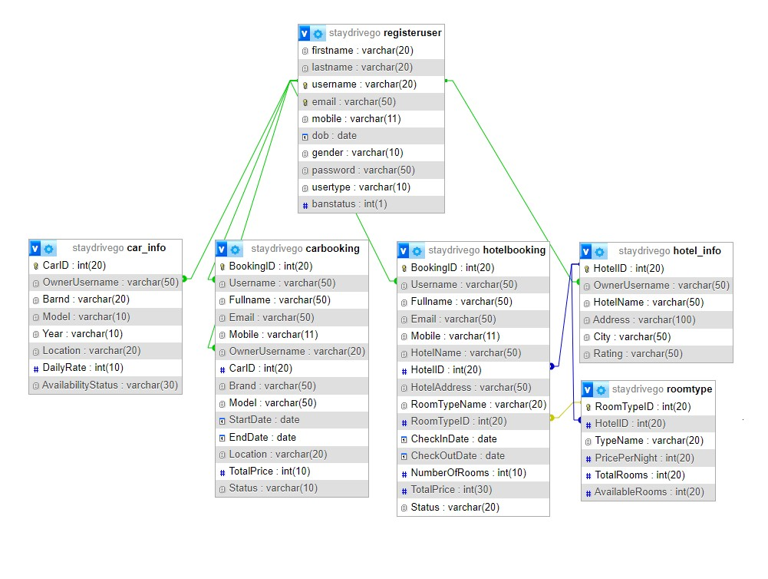

Tools Used:

To develop this project, we have used the following:

• VS Code

• Xampp

System Images against the Specification:

User can search hotel & Car using criteria to check if there are hotels or cars available.

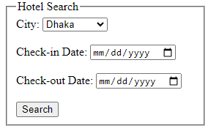

Based on the search results if user selects a hotel or car, can see the details and proceed to book.

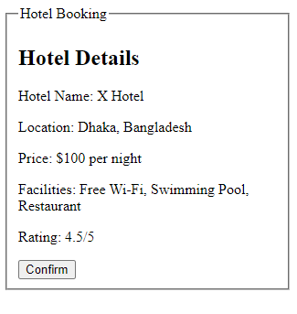

Hotel Owners can register their hotel and list rooms for booking.

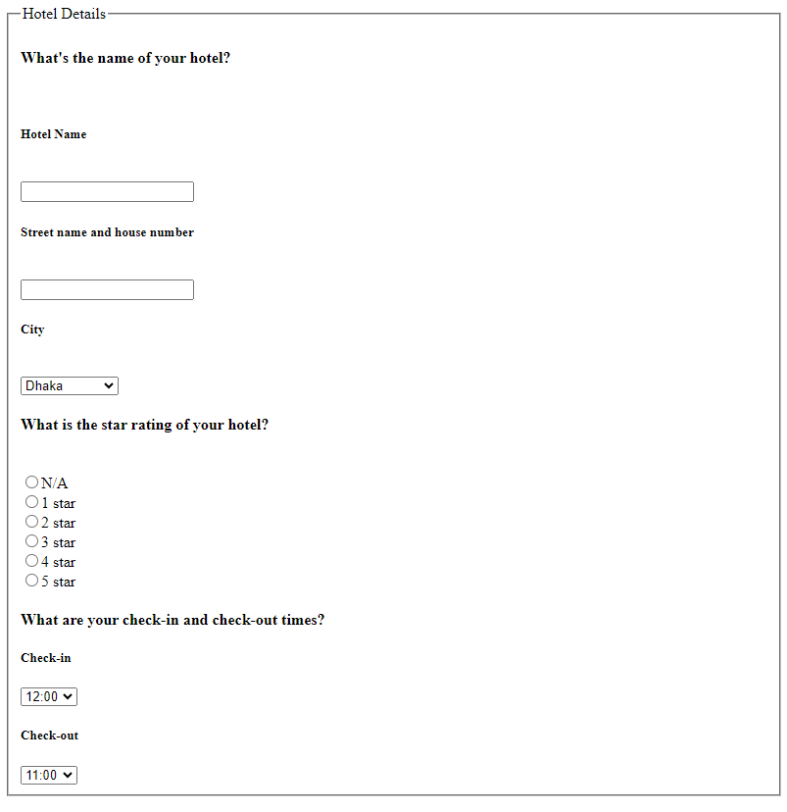 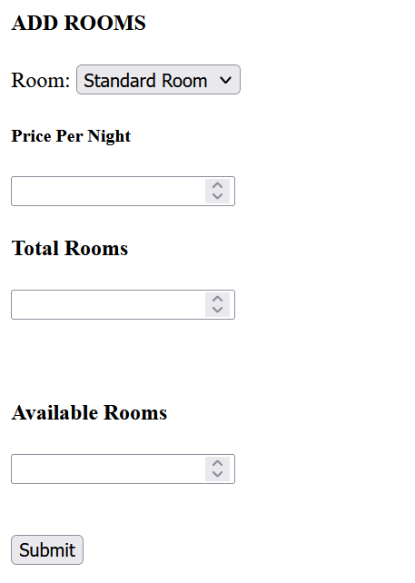

Car owners can list their cars for booking.

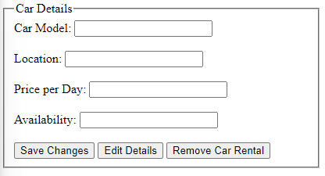

Impact of this Project:

Our project meets the increasing demand for efficient travel planning in modern society and environment where everything is fast paced. As important services such as hotel booking and car rentals are into one platform it directly impacts on how people plan and experience travel. Moreover, it helps service providers to manage services efficiently which is beneficial in the tourism industry. In conclusion this project is an effort of ours to make travel easier for everyone.

Limitations and Possible Future Improvements:

Our project has a few limitations. Firstly, it's designed only for local travel, excluding international options. Secondly, images of hotels, cars,2FA email verification and digital payment integration weren’t possible. Future improvements such as: real-time updates on travel regulations, travel by air, international travel expansion, multiple languages additions, mobile accessibility, and increased collaboration with broader range of local and international service partners will be added to enrich the user experience.

*[Note: Make sure that your report is maximum 10 pages (including cover page). Print (Colored) the report and submit it with spiral bind.]*

|  |  |  |  |  |  |
| --- | --- | --- | --- | --- | --- |
| CO1.1 and CO2.1 Evaluation: Project Report Evaluation | | | | | |
| Project Proposal  (5) | Background  Study  (5) | Requirement Analysis  (5) | Entity  Diagram  (5) | System Images  against the  Specification (5) | Total (25) |
|  |  |  |  |  |  |
|  | | | | | |